**ES Lab 3 Report**

**Programs on Arithmetic Instructions**

Date: 22nd January, 2025

Phirozgar Irani

230905370

CSE 4B: B2

Q1. Subtraction of 2 32-bit numbers

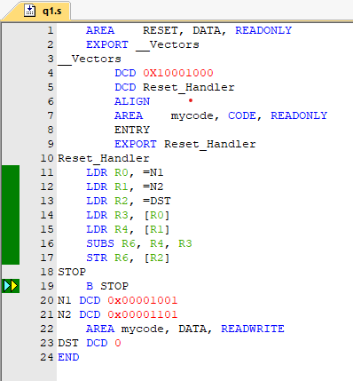

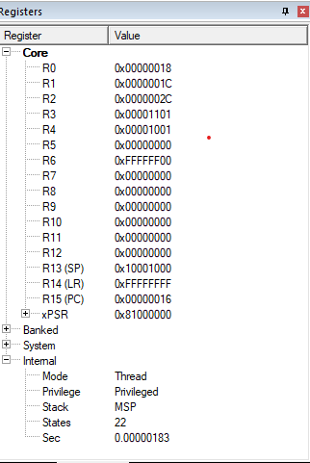

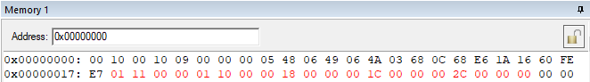

Q2. Multiplication of 2 32-bit numbers ­

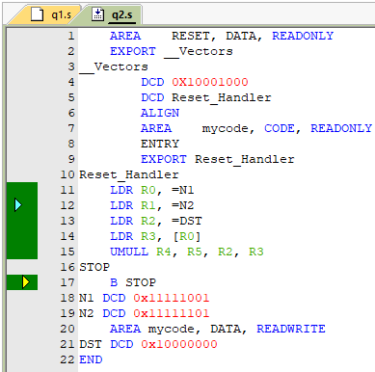

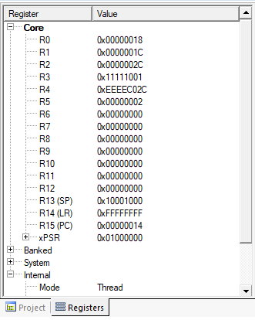

Q3. Implement division by repetitive subtraction

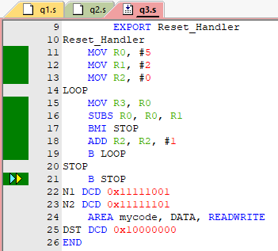

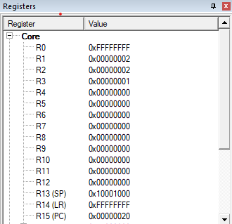

Q4. Sum of ‘n’ natural numbers using MLA instruction

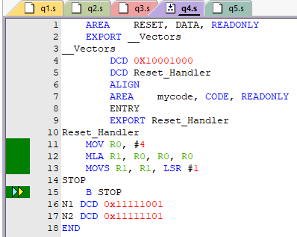

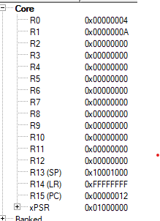

Q5. Add 10 32-bit numbers available in code memory

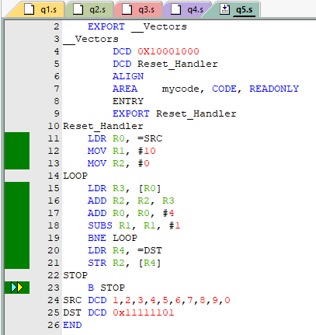

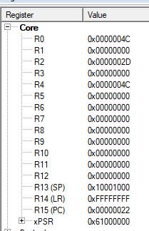

Q6. Generate Fibonacci series

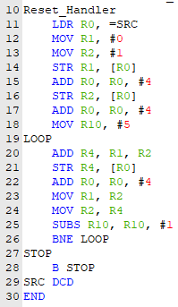

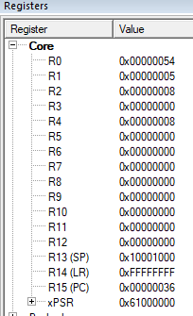

Q7. Find LCM and GCD of 2 8-bit numbers

